David Whitney's Homework 4

Biostatistics 562

Problem 1
For a differential expression simulation study, say 1000 genes are measured on 100 individuals. Let the first 50 individuals constitute class1 and the second 50 individuals be class2. Suppose that expression levels are independent and normally distributed across genes. For individuals in class2, let the last 100 genes be distributed N(0.5,1). For all other genes, assume that the distribution of gene expression is standard normal.

1a. Run one simulation of the experiment and test for differentially expressed genes (genes with mean differences between the two classes) with a false discovery rate cutoff of 10%. How many genes were called significant? How many of these were false discoveries?
We find 37 genes that have a significant mean expression between the two classes and 2 of these were false discoveries, having been observed in the first 900 genes.

1b. Repeat this experiment 1000 times. Of the 100 genes we are searching for, what proportion do we find on average (this is known as the true discovery rate TDR)? Of the genes we call significant what proportion on average are false discoveries? Relate these ideas to the statistical power of our experiment!
After running 1000 of the above simulation studies, we found that the proportion of discoveries that were false discoveries was 0.0905 and the proportion of true discoveries was 0.3189. Power is the probability of rejecting when there is a true effect, so the true discovery rate we estimate is an estimate of the power.

1c. Why might this lead to concern about the reproducibility in these microarray experiments?
If the power of microarray studies is only 0.3189 and the FDR is being controlled at near .0905, then we are unlikely to detect true effects and we will further expect that of the effects that we are detecting, nearly 10% of them will be false discoveries.

Problem 2
We now explore the scenarios under which using FDR as opposed to FWE gives significant additional power.

2a. We consider the study design from Problem 1 but assume now that the mean expression for the last 100 genes of class2 follow a N(2,1) distribution.
When we control the FDR at 10%, we observe a false discovery proportion of 0.0895 and 100% TDR. When we control FWE at .1, we observe a false discovery proportion of 0.0007 and 100% TDR. In this case, the Bonferroni correction outperforms Benjamini-Hochberg by having equal power and a lower Type I error rate.

2b. We consider the study design from Problem 1 but assume now that the mean expression for the last 100 genes of class2 follow a N(0.2,1) distribution.
When controlling FDR, the FDP was 0.08793 and TDR 0.00251. For the Bonferroni correction of FWE, the FDP was 0.07617 and the TPR was 0.00181. Both manners of adjusting the p-values had similar powers in this case.
When the differentially expressed genes followed N(0.01,1), …, N(1.00,1) distributions, controlling the FDR at .10 yielded an estimated false discovery proportion of 0.08933 and true discovery rate of 0.4309. Controlling the FWE instead yielded FDP of 0.003688 and TDR of 0.2146. In this scenario, the TDR obtained by controlling FDR is about twice the power obtained by controlling the FWE.
2c. When will FDR control be more powerful than FWE control?
Consider the baseline genes that are distributed N(0,1). The pdf for these genes is pictured in black below. In blue, we see the N(0.2,1) density, and the N(2,1) in red for the distributions of the differentially expressed genes we explored in parts A and B of the problem. If we are making 1000 comparisons and want to control FWE at the .10 level, then p-values must be less than 0.0001 to be significant. Based on the N(0,1) distribution, this corresponds to a z-score of at least 3.72, which would occur only 4.3% of the time if we sampled from a N(2,1) distribution. In this scenario, we would expect controlling the FDR to be more powerful as it relaxes the cut-off for significance compared to the Bonferroni calculation.
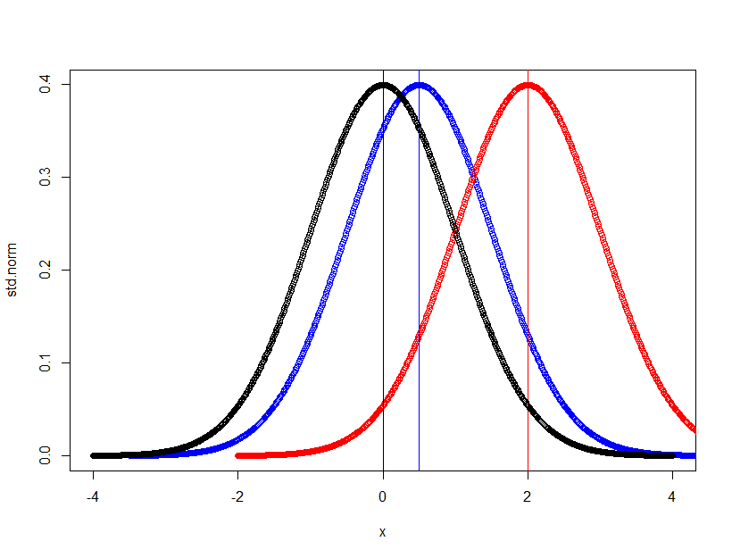

Problem 3
a) If we repeat our simulation study, but assume all gene expression follows a t-distribution with 3 degrees of freedom and keep include just 10 people in each of class1 and class2, then all discoveries will be false discoveries (the distributions are equal). Running our simulation study 1000 times and conducting a t-test across class1 and class2, the proportion of false discoveries was 0.026 when controlling FDR at .10 and 0.025 when controlling the FWE at .10.
b) Supposing that we now know the variance of each gene expression to be 3, we choose to perform a z-test for significance instead. Running our simulation study the proportion of (false) discoveries was 0.021 when controlling FDR at .10 and again 0.021 when controlling FWE at .10.
c) Sampling from the t-distribution with 3 degrees of freedom, we make more false rejections because the t-distribution has heavier tails for small degrees of freedom which makes it more prone to providing outliers than a normal distribution.

